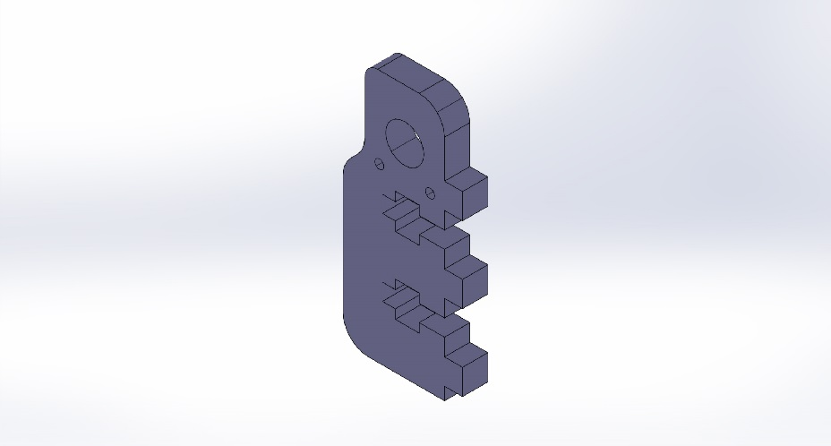 | Simulation of MOUNT, PULLY  Date: Friday, October 25, 2013  Designer: Solidworks  Study name: SimulationXpress Study  Analysis type: Static  Table of Contents  Description 1  Assumptions 2  Model Information 2  Material Properties 3  Loads and Fixtures 3  Mesh Information 4  Study Results 6  Conclusion 8

Description
No Data

Assumptions

Model Information

Model name: MOUNT, PULLY
Current Configuration: Default
Solid Bodies
Document Name and Reference | Treated As | Volumetric Properties | Document Path/Date Modified
#4-40 Tapped Hole1 | Solid Body | Mass:0.00988404 kg  Volume:8.2367e-006 m^3  Density:1200 kg/m^3  Weight:0.0968636 N | H:\ME_450\Linear Book Scanner\Pulleys\MOUNT, PULLY.SLDPRT  Oct 25 22:50:51 2013

Material Properties
Model Reference | Properties | Components
 | Name: Acrylic (Blue)  Model type: Linear Elastic Isotropic  Default failure criterion: Unknown  Yield strength: 4.5e+007 N/m^2  Tensile strength: 7.3e+007 N/m^2 | SolidBody 1(#4-40 Tapped Hole1)(MOUNT, PULLY)

Loads and Fixtures
Fixture name | Fixture Image | Fixture Details
Fixed-1 |  | Entities: 4 face(s)  Type: Fixed Geometry

Load name | Load Image | Load Details
Force-1 |  | Entities: 1 face(s), 1 plane(s)  Reference: Right Plane  Type: Apply force  Values: ---, ---, -40 N

Mesh Information
Mesh type | Solid Mesh
Mesher Used: | Standard mesh
Automatic Transition: | Off
Include Mesh Auto Loops: | Off
Jacobian points | 4 Points
Element Size | 0.0795402 in
Tolerance | 0.00397701 in
Mesh Quality | High

Mesh Information - Details
Total Nodes | 14247
Total Elements | 8566
Maximum Aspect Ratio | 3.6201
% of elements with Aspect Ratio < 3 | 99.6
% of elements with Aspect Ratio > 10 | 0
% of distorted elements(Jacobian) | 0
Time to complete mesh(hh;mm;ss): | 00:00:01
Computer name: | DC3SWP37

Study Results

Name | Type | Min | Max
Stress | VON: von Mises Stress | 170.016 N/m^2  Node: 706 | 7.46836e+006 N/m^2  Node: 10145
MOUNT, PULLY-SimulationXpress Study-Stress-Stress

Name | Type | Min | Max
Displacement | URES: Resultant Displacement | 0 mm  Node: 177 | 0.0514962 mm  Node: 10329
MOUNT, PULLY-SimulationXpress Study-Displacement-Displacement

Name | Type
Deformation | Deformed Shape
MOUNT, PULLY-SimulationXpress Study-Displacement-Deformation

Name | Type | Min | Max
Factor of Safety | Max von Mises Stress | 6.02542  Node: 10145 | 264681  Node: 706
MOUNT, PULLY-SimulationXpress Study-Factor of Safety-Factor of Safety

Conclusion

