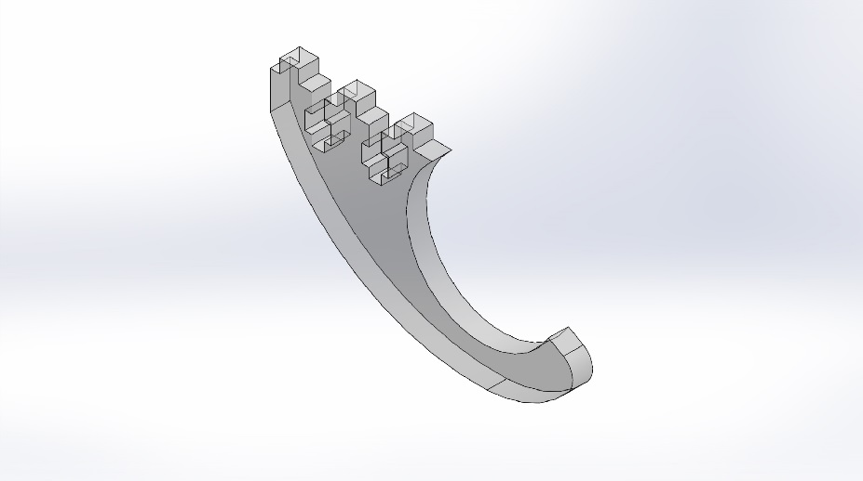 | Simulation of Bracket  Date: Saturday, October 26, 2013  Designer: Solidworks  Study name: SimulationXpress Study  Analysis type: Static  Table of Contents  Description 1  Assumptions 2  Model Information 2  Material Properties 3  Loads and Fixtures 3  Mesh Information 4  Study Results 6  Conclusion 9

Description
No Data

Assumptions

Model Information

Model name: Bracket
Current Configuration: Default
Solid Bodies
Document Name and Reference | Treated As | Volumetric Properties | Document Path/Date Modified
Fillet1 | Solid Body | Mass:0.0202274 kg  Volume:1.68562e-005 m^3  Density:1200 kg/m^3  Weight:0.198229 N | H:\ME_450\Linear Book Scanner\Vacuum Tube\Bracket.SLDPRT  Oct 26 00:09:24 2013

Material Properties
Model Reference | Properties | Components
 | Name: Acrylic (Medium-high impact)  Model type: Linear Elastic Isotropic  Default failure criterion: Unknown  Yield strength: 4.5e+007 N/m^2  Tensile strength: 7.3e+007 N/m^2 | SolidBody 1(Fillet1)(Bracket)

Loads and Fixtures
Fixture name | Fixture Image | Fixture Details
Fixed-1 |  | Entities: 4 face(s)  Type: Fixed Geometry

Load name | Load Image | Load Details
Force-1 |  | Entities: 1 face(s), 1 plane(s)  Reference: Top Plane  Type: Apply force  Values: ---, ---, -5 lbf

Mesh Information
Mesh type | Solid Mesh
Mesher Used: | Standard mesh
Automatic Transition: | Off
Include Mesh Auto Loops: | Off
Jacobian points | 4 Points
Element Size | 0.100982 in
Tolerance | 0.00504911 in
Mesh Quality | High

Mesh Information - Details
Total Nodes | 13278
Total Elements | 7939
Maximum Aspect Ratio | 3.9285
% of elements with Aspect Ratio < 3 | 99.7
% of elements with Aspect Ratio > 10 | 0
% of distorted elements(Jacobian) | 0
Time to complete mesh(hh;mm;ss): | 00:00:01
Computer name: | DC3SWP37

Study Results

Name | Type | Min | Max
Stress | VON: von Mises Stress | 593.27 N/m^2  Node: 10457 | 6.96631e+006 N/m^2  Node: 7934
Bracket-SimulationXpress Study-Stress-Stress

Name | Type | Min | Max
Displacement | URES: Resultant Displacement | 0 mm  Node: 445 | 0.366235 mm  Node: 8214
Bracket-SimulationXpress Study-Displacement-Displacement

Name | Type
Deformation | Deformed Shape
Bracket-SimulationXpress Study-Displacement-Deformation

Name | Type | Min | Max
Factor of Safety | Max von Mises Stress | 6.45966  Node: 7934 | 75850.8  Node: 10457
Bracket-SimulationXpress Study-Factor of Safety-Factor of Safety

Conclusion

